STANDARD SPECIFICATIONS
- Single function shower head
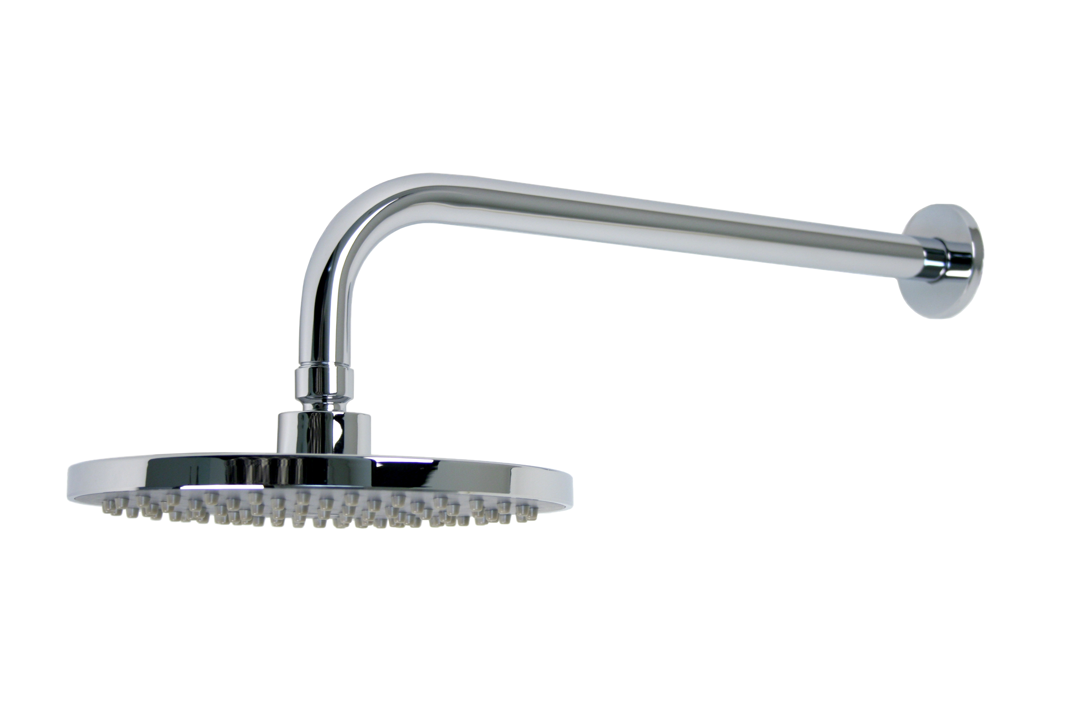
- 2.5gpm flow rate
- 8” round shower head
- 14” long arm

FINISHES INCLUDE
- Chrome (UF91000)
- Brushed nickel (UF91003)

WARRANTY
- Limited lifetime warranty on workmanship and materials to the original purchaser

COMPLIES WITH
- ANSI/ASME A112.18.1
- CSA B125-1
- IAPMO/UPC/CUPC
